**Class______ Student ID_____________ Name_________________ Instructor_____________**

**Date__________________ Pre-class Assignment Grade___________ Final Grade__________**

**Experiment: Michelson Interferometer**

**Ⅰ. Pre-Lab Preparation**

1. Combined with the equivalent optical path diagram of the Michelson interferometer in the figure below, derive the expression for optical path difference *ΔL* = 2*h*cos*α*.

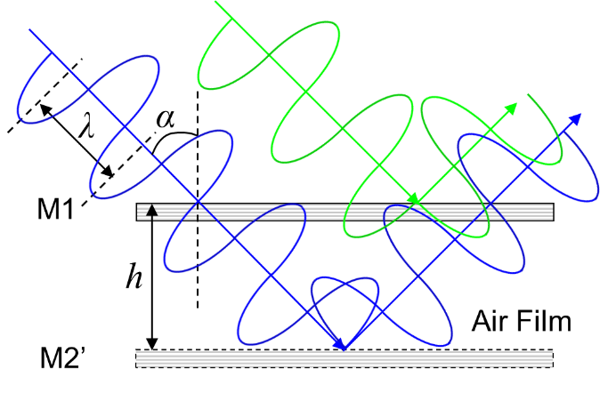

1. In this experiment, you will measure the wavelength *λ* of the He-Ne laser. If the equal-inclination interference ring changes by 50 rings, the micrometer reading corresponding to the moving mirror M2 changes by *d* (**Note:** the actual moving distance of M2 is *d*/20). According to the expression of the optical path difference *ΔL* = 2*h*cos*α*, combined with the approximate condition that the inclination angle *α* corresponding to the central ring is approximately equal to 0, derive the expression of the wavelength *λ* (**Tips:** the interference ring changes by 1 ring for every change of 1 wavelength in the optical path difference).

**II.** **Recording of Original Data**

1.

Table 1 Data for Measuring the Wavelength of He-Ne Laser

|  |  |  |  |  |  |  |
| --- | --- | --- | --- | --- | --- | --- |
| **Number of Ring Changes** | **0** | **50** | **100** | **150** | **200** | **250** |
| **M2 Micrometer Position（mm）** |  |  |  |  |  |  |

2.

Table 2 Data for Measuring the Refractive Index of Air

|  |  |  |  |  |  |  |
| --- | --- | --- | --- | --- | --- | --- |
| **Number of Measurements** | ***ΔP*（mm Hg）** | **50** | **100** | **150** | **200** | **250** |
| **1** | ***N*** |  |  |  |  |  |
| **2** | ***N*** |  |  |  |  |  |
| **3** | ***N*** |  |  |  |  |  |
| **Average Value of *N*** | |  |  |  |  |  |

3. **(Optional)** Observe the equal-inclination interference and equal-thickness interference phenomena of sodium lamp light, and attach photos of the phenomena.

|  |  |
| --- | --- |
| **Instructor**  **Signature** |  |

**Ⅲ.** **Data Processing**

1. Calculate the wavelength of He-Ne laser using the difference method

1. Draw a curve of the number of ring changes *N* versus the pressure change *Δp*, calculate the slope using a graphical method (think about other suitable methods, which can also be used), and find the refractive index of air.
2. **(Optional)** Record and analyze the phenomena, characteristics of equal-inclination interference and equal-thickness interference, attach photos of the phenomena.

**Ⅳ.** **Questions**

1. Summarize the characteristics of non-local interference and local interference.

2. What factors determine the density of interference fringes produced by the Michelson interferometer? What is the law of change?

3. Explain why the instrument needs a compensation plate.